1..Create an html page to display the following nested list

|  |  |
| --- | --- |
|  |  |
|  |  |

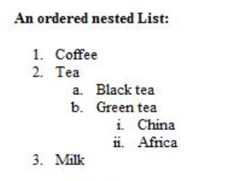

|  |  |
| --- | --- |
|  | <html> |
|  | <head> |
|  | <b>An ordered nested list</b> |
|  | </head> |
|  | <ol type="1"> |
|  | <li>Coffee</li> |
|  | <li>Tea</li> |
|  | <ol type="a"> |
|  | <li>Black tea</li> |
|  | <li>Green tea</li> |
|  | <ol type="i"> |
|  | <li>China</li> |
|  | <li>Africa</li> |
|  | </ol> |
|  | </ol> |
|  | <li>Milk</li> |
|  | </ol> |
|  | </body> |
|  | </html> |
|  |  |
|  |  |

**OUTPUT**

**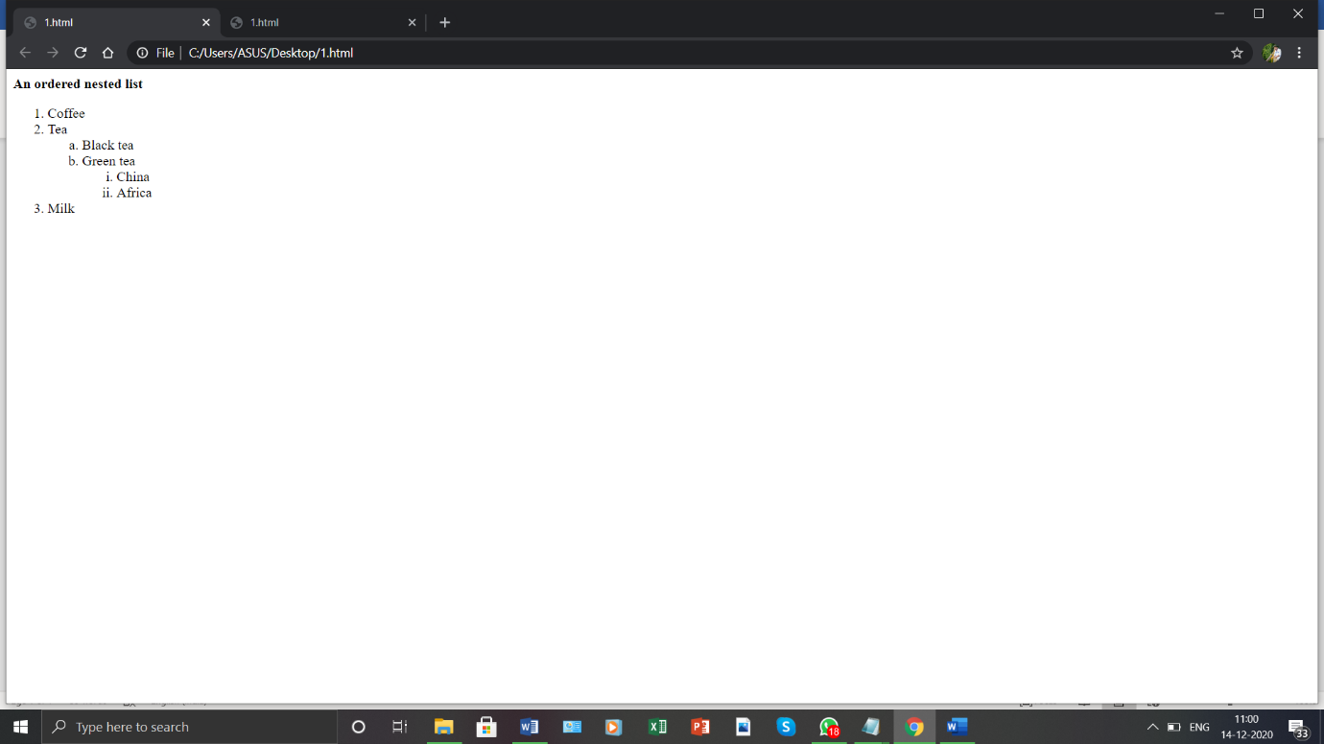**

1. Create links to three different pages on three different websites that should all open in a new window.

**CODE**

|  |  |
| --- | --- |
|  | <html> |
|  | <head> |
|  | <title> |
|  | links |
|  | </title> |
|  | </head> |
|  | <body> |
|  | <h1>links</h1> |
|  | <ul> |
|  | <li><a href="<https://www.google.com/>">Google</a></li> |
|  | <li><a href="[https://www.apple.com//](https://www.apple.com/)">Apple</a></li> |
|  | <li><a href="[https://www.adobe.com///](https://www.adobe.com/)">Adobe</a></li> |
|  | </ul> |
|  | </body> |
|  | </html> |
|  |  |

**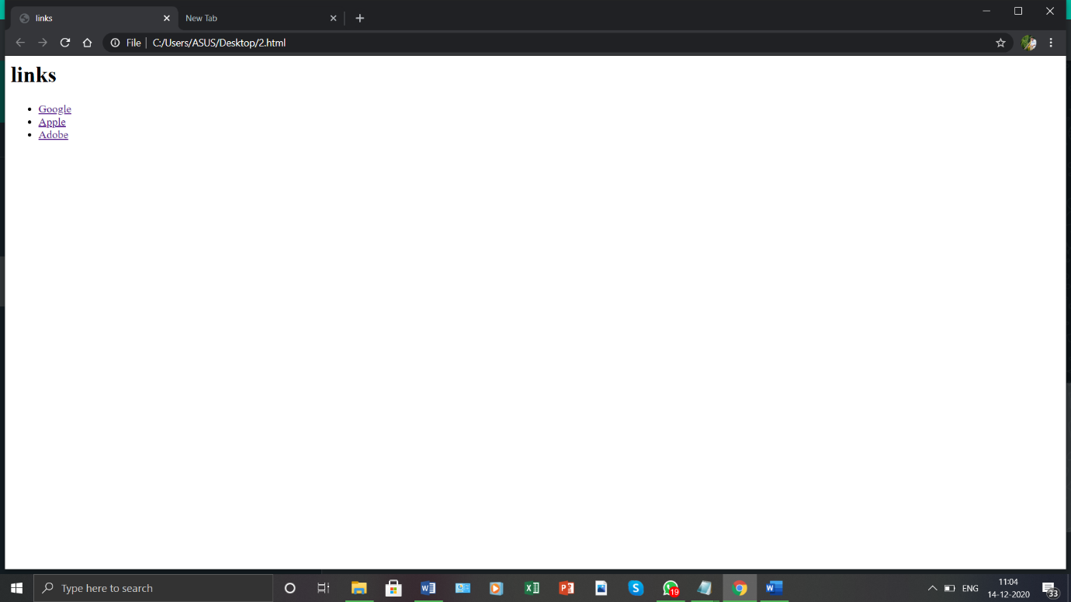**

1. Create a page with a link at the top of it that when clicked will jump all the way to the bottom of the page.

**CODE**

|  |  |
| --- | --- |
|  | <html> |
|  | <head> |
|  | <title> |
|  | page link |
|  | </title> |
|  | </head> |
|  | <body> |
|  | <a href="[#bottom](file:///C:\Users\ASUS\Desktop\3.html#bottom)">Jump to bottom</a><br> |
|  | Google, LLC is an American multinational technology company that specializes in Internet-related services and products, which include online advertising technologies, a search engine, cloud computing, software, and hardware. It is considered one of the Big Five technology companies in the U.S. information technology industry, alongside Amazon, Facebook, Apple, and Microsoft.[9][10][11] |
|  |  |
|  | Google was founded in September 1998 by Larry Page and Sergey Brin while they were Ph.D. students at Stanford University in California. Together they own about 14 percent of its shares and control 56 percent of the stockholder voting power through supervoting stock. They incorporated Google as a California privately held company on September 4, 1998, in California. Google was then reincorporated in Delaware on October 22, 2002.[12] An initial public offering (IPO) took place on August 19, 2004, and Google moved to its headquarters in Mountain View, California, nicknamed the Googleplex. In August 2015, Google announced plans to reorganize its various interests as a conglomerate called Alphabet Inc. Google is Alphabet's leading subsidiary and will continue to be the umbrella company for Alphabet's Internet interests. Sundar Pichai was appointed CEO of Google, replacing Larry Page, who became the CEO of Alphabet. |
|  |  |
|  | The company's rapid growth since incorporation has triggered a chain of products, acquisitions, and partnerships beyond Google's core search engine (Google Search). It offers services designed for work and productivity (Google Docs, Google Sheets, and Google Slides), email (Gmail), scheduling and time management (Google Calendar), cloud storage (Google Drive), instant messaging and video chat (Duo, Hangouts, Chat, and Meet), language translation (Google Translate), mapping and navigation (Google Maps, Waze, Google Earth, and Street View), podcast hosting (Google Podcasts), video sharing (YouTube), blog publishing (Blogger), note-taking (Google Keep and Google Jamboard), and photo organizing and editing (Google Photos). The company leads the development of the Android mobile operating system, the Google Chrome web browser, and Chrome OS, a lightweight operating system based on the Chrome browser. Google has moved increasingly into hardware; from 2010 to 2015, it partnered with major electronics manufacturers in the production of its Nexus devices, and it released multiple hardware products in October 2016, including the Google Pixel line of smartphones, Google Home smart speaker, Google Wifi mesh wireless router, and Google Daydream virtual reality headset. Google has also experimented with becoming an Internet carrier (Google Fiber, Google Fi, and Google Station).[13] |
|  |  |
|  | Google.com is the most visited website worldwide. Several other Google-owned websites also are on the list of most popular websites, including YouTube and Blogger.[14] |
|  | In March 1999, the company moved its offices to Palo Alto, California,[42] which is home to several prominent Silicon Valley technology start-ups.[43] The next year, Google began selling advertisements associated with search keywords against Page and Brin's initial opposition toward an advertising-funded search engine.[44][16] To maintain an uncluttered page design, advertisements were solely text-based.[45] In June 2000, it was announced that Google would become the default search engine provider for Yahoo!, one of the most popular websites at the time, replacing Inktomi.[46][47] |
|  |  |
|  | Google's first servers, showing lots of exposed wiring and circuit boards |
|  | Google's first production server.[48] |
|  | In 2003, after outgrowing two other locations, the company leased an office complex from Silicon Graphics, at 1600 Amphitheatre Parkway in Mountain View, California.[49] The complex became known as the Googleplex, a play on the word googolplex, the number one followed by a googol zeroes. Three years later, Google bought the property from SGI for $319 million.[50] By that time, the name "Google" had found its way into everyday language, causing the verb "google" to be added to the Merriam-Webster Collegiate Dictionary and the Oxford English Dictionary, denoted as: "to use the Google search engine to obtain information on the Internet".[51][52] Additionally, in 2001 Google's Investors felt the need to have a strong internal management, and they agreed to hire Eric Schmidt as the Chairman and CEO of Google [53] |
|  | The year 2012 was the first time that Google generated $50 billion in annual revenue, generating $38 billion the previous year. In January 2013, then-CEO Larry Page commented, "We ended 2012 with a strong quarter ... Revenues were up 36% year-on-year, and 8% quarter-on-quarter. And we hit $50 billion in revenues for the first time last year – not a bad achievement in just a decade and a half."[72] |
|  |  |
|  | In June 2013, Google acquired Waze, a $966 million deal.[73] While Waze would remain an independent entity, its social features, such as its crowdsourced location platform, were reportedly valuable integrations between Waze and Google Maps, Google's own mapping service.[74] |
|  |  |
|  | Google announced the launch of a new company, called Calico, on September 19, 2013, to be led by Apple Inc. chairman Arthur Levinson. In the official public statement, Page explained that the "health and well-being" company would focus on "the challenge of ageing and associated diseases".[75] |
|  |  |
|  |  |
|  | Entrance of building where Google and its subsidiary Deep Mind are located at 6 Pancras Square, London |
|  | On January 26, 2014, Google announced it had agreed to acquire DeepMind Technologies, a privately held artificial intelligence company from London.[76] Technology news website Recode reported that the company was purchased for $400 million though it was not disclosed where the information came from. A Google spokesman would not comment of the price.[77][78] The purchase of DeepMind aids in Google's recent growth in the artificial intelligence and robotics community.[79] |
|  |  |
|  | According to Interbrand's annual Best Global Brands report, Google has been the second most valuable brand in the world (behind Apple Inc.) in 2013,[80] 2014,[81] 2015,[82] and 2016, with a valuation of $133 billion.[83] |
|  |  |
|  | On August 10, 2015, Google announced plans to reorganize its various interests as a conglomerate called Alphabet. Google became Alphabet's leading subsidiary, and will continue to be the umbrella company for Alphabet's Internet interests. Upon completion of the restructure, Sundar Pichai became CEO of Google, replacing Larry Page, who became CEO of Alphabet.[84][85][86] |
|  |  |
|  | As of October 2016, Google operates 70 offices in more than 40 countries.[87] |
|  |  |
|  | Google.com is the most visited website worldwide. Several other Google-owned websites also are on the list of most popular websites, including YouTube and Blogger.[14] |
|  |  |
|  | On August 8, 2017, Google fired employee James Damore after he distributed a memo throughout the company which argued that bias and "Google's ideological echo chamber" clouded their thinking about diversity and inclusion, and that it is also biological factors, not discrimination alone, that cause the average woman to be less interested than men in technical positions.[88] Google CEO Sundar Pichai accused Damore in violating company policy by "advancing harmful gender stereotypes in our workplace", and he was fired on the same day.[89][90][91] New York Times columnist David Brooks argued Pichai had mishandled the case, and called for his resignation.[92][93] |
|  |  |
|  | Between 2018 and 2019, tensions between the company's leadership and its workers escalated as staff protested company decisions on internal sexual harassment, a censored Chinese search engine, and a military drone artificial intelligence, which had been seen as areas of revenue growth for the company.[94][95] On October 25, 2018, The New York Times published the exposé, "How Google Protected Andy Rubin, the ‘Father of Android’". The company subsequently announced that "48 employees have been fired over the last two years" for sexual misconduct.[96] On November 1, 2018, more than 20,000 Google employees and contractors staged a global walk-out to protest the company's handling of sexual harassment complaints.[97][98] Later in 2019, some workers accused the company of retaliating against internal activists.[95] |
|  |  |
|  | On March 19, 2019, Google announced that it would enter the video game market, launching a cloud gaming platform called Stadia.[99] |
|  |  |
|  | On June 3, 2019, the United States Department of Justice reported that it would investigate Google for antitrust violations.[100] This led to the filing of an antitrust lawsuit in October 2020, on the grounds the company had abused a monopoly position in the search and search advertising markets.[101] |
|  |  |
|  | In December 2019, it was reported that former PayPal Chief Operating Officer Bill Ready would become Google's new commerce chief. Ready's role will not be directly involved with Google Pay.[102] |
|  |  |
|  | In April 2020, due to the COVID-19 pandemic, Google announced several cost-cutting measures. Such measures included slowing down hiring for the remainder of 2020, except for a small number of strategic areas, recalibrating the focus and pace of investments in areas like data centers and machines, and non-business essential marketing and travel.[103]</p> |
|  |  |
|  | <h2 id="bottom">bottom</h2> |
|  | </body> |
|  | </html> |
|  |  |

**OUTPUT**

**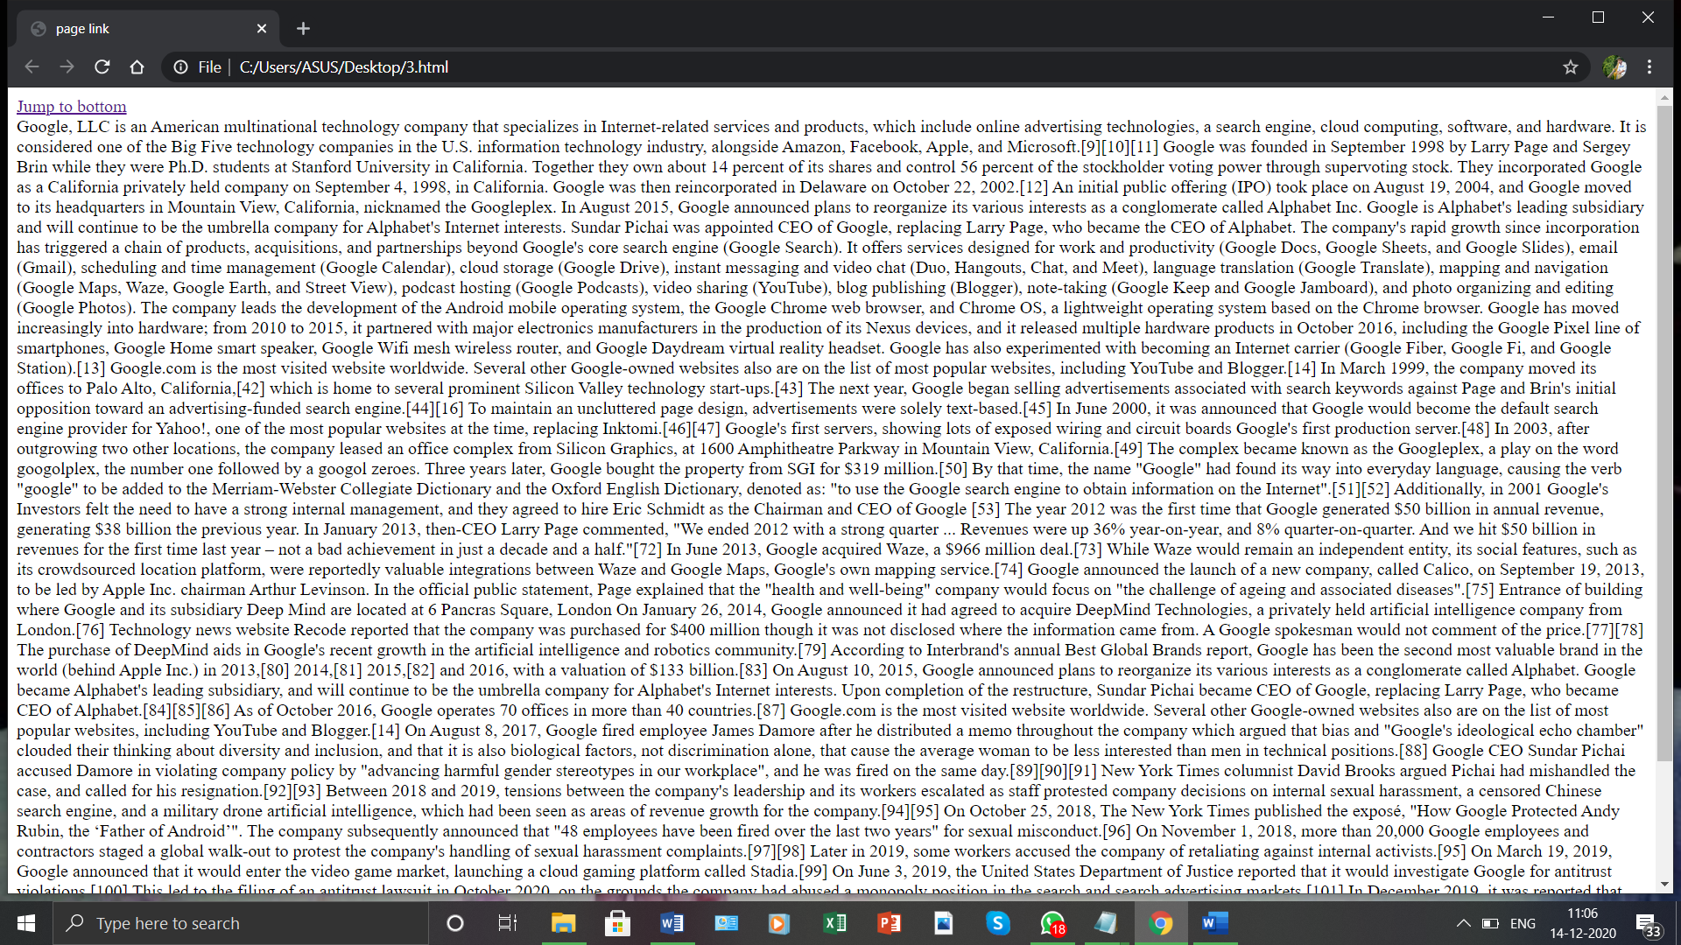**

|  |  |  |  |  |  |  |  |  |  |  |  |  |  |  |  |  |  |  |  |  |  |  |  |  |  |  |  |  |  |  |  |  |  |  |  |  |
| --- | --- | --- | --- | --- | --- | --- | --- | --- | --- | --- | --- | --- | --- | --- | --- | --- | --- | --- | --- | --- | --- | --- | --- | --- | --- | --- | --- | --- | --- | --- | --- | --- | --- | --- | --- | --- |
| 1. Display three different images. Skip two lines between each image. Each image should have a heading.   **CODE**   |  |  | | --- | --- | |  | <html> | |  | <head> | |  | <title> | |  | images | |  | </title> | |  | </head> | |  | <body> | |  | <h1>Images</h1> | |  | <h2>image1</h2> | |  | <img src="[cat1.jpg](file:///C:\Users\ASUS\Desktop\cat1.jpg)"width="299" height="164"><br><br> | |  | <h2>image2</h2> | |  | <img src="[cat2.jfif](file:///C:\Users\ASUS\Desktop\cat2.jfif)"><br><br> | |  | <h2>image3</h2> | |  | <img src="[cat3.jfif](file:///C:\Users\ASUS\Desktop\cat3.jfif)"><br><br> | |  | </body> | |  | </html> | |  |  |   **OUTPUT** | |  |
| 1. DIisplay an image that when clicked will link to a search engine of your choice in a different window   **CODE**   |  |  | | --- | --- | |  | <html> | |  | <head> | |  | <title> | |  | search engine | |  | </title> | |  | </head> | |  | <body> | |  | <h2>click on the image</h2> | |  | <a target="\_blank" href="<https://www.apple.com>"> | |  | <img width="300" height="300" src="[apple.png](file:///C:\Users\ASUS\Desktop\apple.png)"> | |  | </a> | |  | </body> | |  | </html> | |  |  |   **OUTPUT** | |  |
| |  |  |  |  |  |  |  |  |  |  |  |  |  |  |  |  |  |  |  |  |  |  |  |  |  |  |  |  |  |  |  |  |  |  |  |  |  |  |  |  |  |  |  |  |  |  |  |  |  |  |  |  |  |  |  |  |  |  |  |  |  |  |  |  |  |  |  |  |  |  |  |  |  |  |  |  |  |  |  |  |  |  |  |  |  |  |  |  |  |  |  |  |  |  |  |  |  |  |  |  |  |  |  |  |  |  |  |  |  |  |  |  |  |  |  |  |  |  |  |  |  |  |  |  |  |  |  |  |  |  |  |  |  |  |  |  |  |  |  |  |  |  |  |  |  |  |  |  | | --- | --- | --- | --- | --- | --- | --- | --- | --- | --- | --- | --- | --- | --- | --- | --- | --- | --- | --- | --- | --- | --- | --- | --- | --- | --- | --- | --- | --- | --- | --- | --- | --- | --- | --- | --- | --- | --- | --- | --- | --- | --- | --- | --- | --- | --- | --- | --- | --- | --- | --- | --- | --- | --- | --- | --- | --- | --- | --- | --- | --- | --- | --- | --- | --- | --- | --- | --- | --- | --- | --- | --- | --- | --- | --- | --- | --- | --- | --- | --- | --- | --- | --- | --- | --- | --- | --- | --- | --- | --- | --- | --- | --- | --- | --- | --- | --- | --- | --- | --- | --- | --- | --- | --- | --- | --- | --- | --- | --- | --- | --- | --- | --- | --- | --- | --- | --- | --- | --- | --- | --- | --- | --- | --- | --- | --- | --- | --- | --- | --- | --- | --- | --- | --- | --- | --- | --- | --- | --- | --- | --- | --- | --- | --- | --- | --- | --- | --- | | 1. Create the following Html Page using appropriate form controls   Image result for forms in html example  **CODE**   |  |  | | --- | --- | |  | <html> | |  | <head> | |  | <style> | |  | table th,td{ | |  | border:0px solid black; | |  | border-collapse:collapse; | |  | } | |  | </style> | |  | </head> | |  | <body> | |  | <table border="1" align="center" width='50%' bgcolor='gold'> | |  | <tr> | |  | <th colspan="4" align="center"> The World Of Fruit</th> | |  | </tr> | |  | </table> | |  | <table border="1" align="center" width="50%" bgcolor="yellow"> | |  | <tr> | |  | <th colspan="4" align="center">Fruit Survey</th> | |  | </tr> | |  | <tr> | |  | <td align="center">Name</td> | |  | <td><input type="text" name="name"><br><br></td> | |  | </tr> | |  | <tr> | |  | <td align="center">Address</td> | |  | <td><input type="text" name="address"><br><br></td> | |  | </tr> | |  | <tr> | |  | <td align="center">Email</td> | |  | <td><input type="text" name="name"><br><br></td> | |  | </tr> | |  | <tr> | |  | <td align="center" rowspan="2">How many pieces of fruit<br>do you eat per day?</td> | |  | <td><input type="radio" name="fruits">0</td> | |  | </tr> | |  | <tr> | |  | <td><input type="radio" name="fruits">1</td> | |  | </tr> | |  | <tr> | |  | <td></td> | |  | <td><input type="radio" name="fruits">2</td> | |  | </tr> | |  | <tr> | |  | <td></td> | |  | <td><input type="radio" name="fruits">More than 2<br><br></td> | |  | </tr> | |  | <tr> | |  | <td align="center">My favourite fruit</td> | |  | <td> | |  | <select multiple> | |  | <option>Apple</option> | |  | <option>Banana</option> | |  | <option>Plum</option> | |  | <option>jackfruit</option> | |  | <option>guava</option> | |  | <option>orange</option> | |  | </select><br><br> | |  | </td> | |  | </tr> | |  | <tr> | |  | <td align="center">Would you like brochure?</td> | |  | <td><input type="checkbox" name="check"></td> | |  | </tr> | |  | <tr> | |  | <td align="center"></td> | |  | <td><br><br> | |  | <button>submit</button><br><br> | |  | </td> | |  | </tr> | |  | </table> | |  | </body> | |  | </html> | |  |  | ** |  | | |  |
| |  |  | | --- | --- | |  |  | | 1. 7. Create an image map for ‘Kerala Map’. Map at least 3 districts so that when you click on that particular district the details regarding that district(**eg: population, Area, Tourist Spots(with images), Monuments, Interesting Facts )** should be displayed on a new page.   **CODE**   |  |  | | --- | --- | |  | <html> | |  | <body> | |  | <h1>Kerala Map</h1> | |  | <p><h2> kottayam,idukki,wayanad<h2/></p> | |  | <center><img src="[kerala1.jpg](file:///C:\Users\ASUS\Desktop\kerala1.jpg)"> | |  | <area shape="circle" coords="140,278,20" alt="kottayam" | |  | href="<https://en.wikipedia.org/wiki/Kottayam>" target="\_blank"> | |  | <area shape="circle" coords="164,340,20" alt="idukki" | |  | href="<https://en.wikipedia.org/wiki/Idukki_district>" target="\_blank"> | |  | <area shape="circle" coords="24,28,20" alt="wayanad" | |  | href="<https://en.wikipedia.org/wiki/Wayanad_district>" target="\_blank"> | |  | </map> | |  | </body> | |  | </html> | |  |  | ** |  | |

8.construct this puzzle looking thing

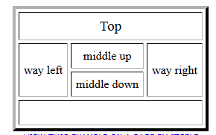

**CODE**

|  |  |
| --- | --- |
|  | <html> |
|  | <head> |
|  | </head> |
|  | <body> |
|  | <header> |
|  | <div style="padding-left: 450px;padding-top: 200px"> |
|  | <table border="3px" width="300" height="150"> |
|  | <tr > |
|  | <td colspan="3"><center>Top</center></td> |
|  | </tr> |
|  | <tr > |
|  | <td rowspan="2"><center>way left</center></td> |
|  | <td ><center>middle up</center></td> |
|  | <td rowspan="2"><center>way right</center></td> |
|  | </tr> |
|  | <tr > |
|  | <td ><center>middle down</center></td> |
|  | </tr> |
|  | <tr> |
|  | <td colspan="3"><center>Bottom</center></td> |
|  | </tr> |
|  | </table> |
|  | </div> |
|  | </header> |
|  | </body> |
|  | </html> |
|  |  |

**OUTPUT**

****

1. Make up three image links for 3 web browsers and put them in a borderless table. Construct the table so that there is just a little space between the images.

**CODE**

|  |  |
| --- | --- |
|  | <html> |
|  | <head> |
|  | <title> |
|  | Img |
|  | </title> |
|  | </head> |
|  | <body> |
|  | <table> |
|  | <tr> |
|  | <td><a target="\_blank" href="<https://en.wikipedia.org/wiki/BMW>"> |
|  | <img width="300" height="200" src="[bmw.jfif](file:///C:\\Users\\ASUS\\Desktop\\bmw.jfif" \t "_blank)"> |
|  | </a><br><br> |
|  | </td> |
|  | </tr> |
|  | <tr> |
|  | <td><a target="\_blank" href="<https://en.wikipedia.org/wiki/Mercedes-Benz>"> |
|  | <img width="300" height="200" src="[benz.jpg](file:///C:\Users\ASUS\Desktop\benz.jpg)"> |
|  | </a><br><br> |
|  | </td> |
|  | </tr> |
|  | <tr> |
|  | <td><a target="\_blank" href="<https://en.wikipedia.org/wiki/Nike,_Inc.>"> |
|  | <img width="300" height="200" src="[nike.jpg](file:///C:\Users\ASUS\Desktop\nike.jpg)"> |
|  | </a> |
|  | </td> |
|  | </tr> |
|  | </table> |
|  | </body> |
|  | </html> |
|  |  |

**OUTPUT**

**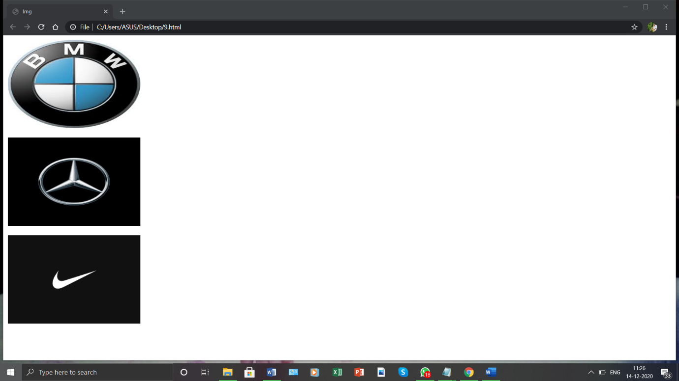**

10.Create the following html page using frames

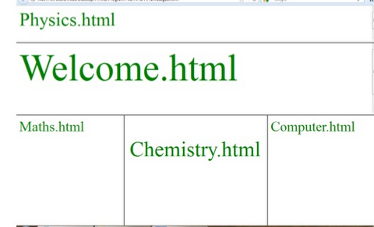

**CODE**

|  |  |
| --- | --- |
|  | <!DOCTYPE html> |
|  | <html> |
|  | <head> |
|  | <title>Frame tag</title> |
|  | </head> |
|  |  |
|  | <frameset rows="20%,30%,40%"> |
|  | <frame src="[10.10.html](file:///C:\Users\ASUS\Desktop\10.10.html)"> |
|  | <frame src="[10.2.html](file:///C:\Users\ASUS\Desktop\10.2.html)"> |
|  |  |
|  | <frameset cols="30%,40%,30%"> |
|  | <frame src="[10.3.html](file:///C:\Users\ASUS\Desktop\10.3.html)"> |
|  | <frame src="[10.4.html](file:///C:\Users\ASUS\Desktop\10.4.html)" > |
|  | <frame src="[10.5.html](file:///C:\Users\ASUS\Desktop\10.5.html)" > |
|  | </frameset> |
|  | </frameset> |
|  |  |
|  | </html> |
|  |  |
|  |  |

**10.10**

|  |  |
| --- | --- |
|  |  |
|  | <!DOCTYPE html> |
|  | <html> |
|  | <head> |
|  | </head> |
|  | <body> |
|  | <div> |
|  | <h1 style="font-size:300%; color:green;" >Physics.html</h1> |
|  | </div> |
|  | </body> |
|  | </html> |
|  |  |
|  |  |

**10.2**

|  |  |
| --- | --- |
|  |  |
|  | <!DOCTYPE html> |
|  | <html> |
|  | <head> |
|  | </head> |
|  | <body> |
|  | <div> |
|  | <h1 style="font-size:300%; color:green;" >Physics.html</h1> |
|  | </div> |
|  | </body> |
|  | </html>  **10.3**   |  |  | | --- | --- | |  |  | |  | <!DOCTYPE html> | |  | <html> | |  | <head> | |  | </head> | |  | <body> | |  | <div> | |  | <h1 style="font-size:300%; color:green;" >Physics.html</h1> | |  | </div> | |  | </body> | |  | </html> | |  |  | |  |  |   **10.4**   |  |  | | --- | --- | |  |  | |  | <!DOCTYPE html> | |  | <html> | |  | <head> | |  | </head> | |  | <body> | |  | <div> | |  | <h2 style="text-align:center;font-size:450%;color:green;">Chemistry.html</h2> | |  | </div> | |  | </body> | |  | </html> | |  |  | |  |  |   **10.5**   |  |  | | --- | --- | |  |  | |  | <!DOCTYPE html> | |  | <html> | |  | <head> | |  | </head> | |  | <body> | |  | <div> | |  | <h2 style="font-size:300%;color:green;">Computer.html</h2> | |  | </div> | |  | </body> | |  | </html> | |  |  |   **OUTPUT** |
|  |  |
|  |  |

11.Create an HTML page using frames which is similar to the following one. In the left frame provide hyperlinks to 3 important monuments in world. On clicking that hyperlink an image of the monument should be displayed in right frame with suitable description

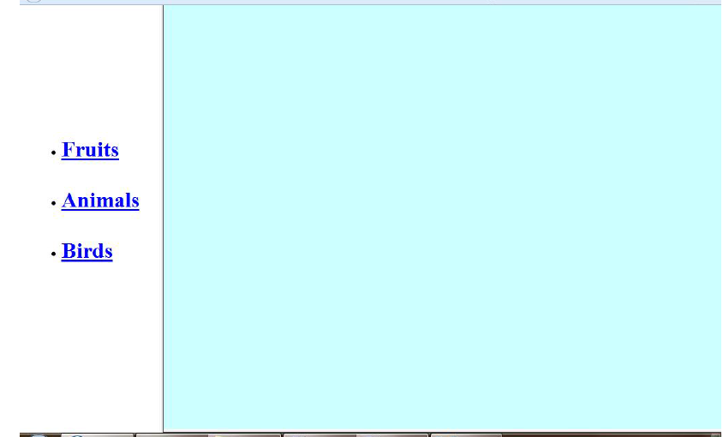

**CODE**

|  |  |
| --- | --- |
|  | <!DOCTYPE html> |
|  | <html> |
|  | <head> |
|  | <title>HTML Target Frames</title> |
|  | </head> |
|  | <frameset cols = "200,\*"> |
|  | <frame src = "[11.1.html](file:///C:\Users\ASUS\Desktop\11.1.html)"/> |
|  | <frame src = "[11.2.html](file:///C:\Users\ASUS\Desktop\11.2.html)"/> |
|  | </frameset> |
|  | </html> |
|  |  |

**11.1**

|  |  |
| --- | --- |
|  | <!DOCTYPE html> |
|  | <html> |
|  | <body bgcolor = "#A5E8EE"> |
|  | </body> |
|  | </html> |
|  |  |

**11.2**

|  |  |
| --- | --- |
|  | <!DOCTYPE html> |
|  | <html> |
|  | <body > |
|  | <br> |
|  | <br> |
|  | <br> |
|  | <br> |
|  | <br> |
|  | <br> |
|  | <br> |
|  | <br> |
|  | <ul type="dot"> |
|  | <li> <a href ="<https://www.tajmahal.gov.in/>" target = "display" style="color:blue;font-size:150%;">taj mahal</a></li> |
|  | <br> |
|  | <br> |
|  | <li><a href = "<https://www.goldentempleamritsar.org/>" target = "display" style="color:blue;font-size:150%;">Golden temple</a></li> |
|  | <br> |
|  | <br><li><a href = "<http://www.qutubminar.org/>" target = "display" style="color:blue;font-size:150%;">Qutb Minar</a></li> |
|  | </ul> |
|  | </body> |
|  | </html> |
|  |  |

**OUTPUT**

****